Matthew Curry, Dylan Wasilnak

Professor Berkove

Mathematics 301

12/12/2018

Community Center Calculus: Optimizing the Transportation Schedule of the Lafayette Community Engagement Center

**Summary:**

The following paper details a mathematical model used to determine the cheapest way for the Landis Community Engagement Center of Lafayette College to cover its transportation needs. Using integer programming, a type of linear programming that utilizes integer and binary variables, the model assigns the different forms of transportation to the various trips needed to be covered all while minimizing an equation describing the overall cost of transportation generated from estimating the cost of the various methods. For our cost estimation, we use several reasonable assumptions in conjunction with cost data provided to us by the Community Engagement Center. We use the “open solver” add-on to Excel to solve this problem, as the standard Excel solver is incapable of solving a problem with the number of variables (hereby referred to as “decision variables” using the language of linear programming) posed by our model. Our model minimizes the cost equation subject to various constraints that ensure only one method of transportation is used for each trip and that only available methods (i.e only those that can be used on a given trip due to various stipulations) are used on a given trip. Our constraints feature binary decision variables corresponding to whether or not a given trip is covered by the method of transportation corresponding to the variable. If the answer is “yes”, these variables assume values of 1 which are either directly or indirectly reflected in our cost minimization equation, which involves these variables being multiplied against our cost data. So, if a given trip is covered by a given form of transportation, the corresponding charges are reflected in the cost equation, and its minimization forces different variables to assume values of 1 or 0, corresponding to the minimized cost and thus optimal transportation schedule. Ultimately, our model produces a minimum cost of transportation of $17,540, which by our estimates saves the Landis Center $8,960. Our program yields a solution involving the Landis center leasing 4 vans which are primarily driven by student drivers from each program, hiring additional student drivers, using Uber, and using Lafayette’s free shuttle service, the LCAT.

**Problem:**

The problem poses the issue of optimizing the scheduling of transportation for the Landis Community Engagement Center to its various program sites while minimizing the total cost to pay for these various methods of transportation. To accomplish this, several transportation options were either presented to us by the center or added at our discretion. Currently, the center relies on the college’s shuttle service, hereby referred to as the LCAT, to cover fixed trips to drop students off at various programs. The center also currently leases 4 vans from the College itself which are each capable of holding 7 students, and also rents a van on a daily basis. These leased and rented vans are primarily driven by students whom are attending the program the van is transporting the students to, although the center also has a staff member drive students, hereby referred to by her name Kim, whom the center pays on a fixed rate. We also considered using Uber drivers due to their flexibility in use and relatively low cost to provide additional transportation support, as well as the option of paying students to drive vans, hereby referred to as “hired drivers”, again as a relatively inexpensive way to yield more transportation options. One of the more challenging aspects of this program lies in the fact that the different methods of transportation are charged over different units of time. Kim is charged on an hourly basis, the use of leased vans involves a half semesterly charge, the rented vans are charged daily, the Uber is charged per trip, and the hired drivers are paid hourly. The different time frames are particularly troublesome when dealing with the vans. This is because if it is determined that a rented or leased van is used for a given trip, that same van can be used to cover other trips that occur during that day if the van is rented or anytime if the van is leased. The other primary difficulty of this model was dealing with the fact that if the times associated with two different locations are too close together, one method of transportation may not have the time to get to both. Our model introduced several constraints to deal with these difficulties, and several assumptions to help build these constraints. The following assumptions we derived to simplify our model:

1. We assume that the LCAT shuttle route is fixed.
2. We assume that each leased van incurs an identical charge
3. We assume that hired drivers idle at their destination and do not incur extra gas costs while waiting for a particular program to end
4. We assume that the yearly gas cost provided to us can be scaled down to the per trip gas cost
5. We assume that rented van gas costs are the same as leased van gas costs
6. We assume that all destinations are a 15 minute drive apart from one another
7. We assume that the cost per Uber ride is the same. This is based on an assumption provided to us by the Landis Center discussed in the following section that assumes that every trip requires the same driving time. So, we looked at Uber’s website to see how expensive a ride to the Easton Public Library, one of the program locations, would cost, and assumed this cost was the same for all trips. We looked at Uber X prices and multiplied this by 2, as each Uber X holds 4 people and the next most spacious option, the Uber XL, holds 6, so in order to hold the full 7 people that participate in the programs (an assumption mentioned later), the cheapest approach would be to purchase 2 Uber X’s. We arrived at a figure of $15 per Uber trip from this assumption.
8. For the student driver wage, we assumed that drivers would be paid at a wage of $10 per hour. This was based on the notion that student work study jobs generally pay $8-$9 per hour which is known because one of this paper’s writers has a work study job. We rounded up to ten to be more conservative and also because we felt this job deserves higher pay due to the shorter work hours it provides. Each destination requires half an hour of driving, as it takes 15 minutes to drive to a destination and 15 minutes to drive back from a destination, so we split the $10 in half to calculate the per trip cost of hiring a student driver.
9. We assume that we can acquire as many student drivers as needed to fulfill the necessary trips. Because we assume that we can pay them less than the current hired driver Kim’s rate, we know that inevitably our program would never tell us to use Kim to cover a route because it has the ability to assign a cheaper student driver. So, we don’t explicitly include Kim in our model to make more condensed equations and eliminate unnecessary computation from the Excel program.

The following set of assumptions and data were provided to us by the Landis Center:

1. Lafayette Colleges currently charges a total of $2,100 for van use (4 vans) on a quarterly basis. Because we assume each of the vans incurs an identical charge, this means that each of these vans costs $525 each half semester
2. 7 students take part in each program
3. If a student is driving a van to the site of the program for which they are taking part in, that van must remain at that site until the program ends that day
4. When a driver uses one van to take students to two places, those places either being program locations or Lafayette College, the time between when the students need to be dropped off must be at least half an hour in order for the driver to have enough time to cover both trips
5. The Landis Center can rent an Enterprise van for about 70$/day
6. Kim, the hired staff member van driver, costs the Landis Center $27/hour. She currently drives 9 hours a week for the center. This corresponds to a cost of $6800 per year multiplying the hourly cost of $27 per hour times 9 hours a week times 28 weeks in a year
7. All current program times are fixed
8. The weekly schedule is repeated each week
9. $1300 of gas is currently spent per year for total gas costs. Based on our assumptions related to each van having the same cost, and also each trip having the same length, we can divide this number by the 28 weeks in the year to get the per week cost and then divide that number by the total number of trips that use vans, which we assume to be a total of 96 by removing trips that are covered by the program shuttle, which allows us to arrive at a current per trip gas cost of $0.48. We use this per trip figure to account for gas cost in our program
10. The center spends approximately $1500 a semester on bus trips, which we assumed could be split in half to reflect a half semesterly cost of $750
11. The Landis Center currently spends $10,000 a year to rent a van per day

**The Model:**

The following equations detail the minimization equation and the various constraints that our model considers. All binary variables assume a value of 1 if the condition they deal with is true and assume a value of 0 otherwise. Before we discuss the variables, it is critical to understand our use of indices throughout this problem. In reality, our linear program features thousands of constraints, but most of these are essentially the same constraint only differing in that they represent a different van, day, or route. Thus, our variables will feature several different indices to simplify the number of constraints, and these indices are detailed below:

|  |  |
| --- | --- |
| Indicie | Explanation |
| $$k$$ | Anytime the letter $k$ is used as an index, we are referring to the particular variable for the $k^{th}$ day. The Landis center runs programs over the week days, meaning that we will allow $k$ to run from 1 to 5 |
| $$i$$ | Anytime the letter $i$ is used as an index, we are referring to the particular variable for the $i^{th}$ van. Our program has the potential to assign 10 leased vans to be used in the week and 10 rented vans to be used in a given day, so $i$ will run from 1 to 10 |
| $$j$$ | The letter $j$ is never used explicitly to represent an index, but is included in this explanation to better understand the two following indices. “ $j$” represents the locations that are covered on a particular day “ $k$”. So, if on a particular day 8 programs are covered, $j$ will run from 1 to 8. |
| $$b$$ | The letter $b$ is an index that represents all the trips that drive to programs for a particular day. Whenever the indice $b$ is used, we are referring to the particular variable for the $b^{th}$ trip which is driving to the $j^{th}$ location. So, $b$ runs through the same set of numbers that $j$ runs for a particular day |
| $$f$$ | The letter $f$ is an index that represents all the trips that drive home from programs for a particular day. Whenever the index $f$ is used, we are referring to the particular variable for the $f^{th}$ trip which is driving back from the the $j^{th}$ location. So, $f$ runs through the same set of numbers that $j$ and $b$ runs for a particular day |

Now that we have discussed the different indices, we can discuss the different variables in our program. Below is a table of the various variables used. All 2 lettered variables signify one variable, not multiplication:

|  |  |
| --- | --- |
| Variables | Explanation Of Their Meaning |
| $${CT}_{}$$ | The Total Cost of Transportation for the Landis Center over a half semester period. |
| $$D_{k}$$ | The costs associated with a particular day, with $k$ running between 1 and 5 to represent the working days in which the Landis center runs programs |
| $${LS}_{ibk}$$ | These represent binary decision variables that assumes values of one if the $i^{th}$ leased van is driven for the $b^{th}$ outgoing trip on the $k^{th}$ day by a student participating in the program they drive to |
| $${LS}_{ifk}$$ | These represent binary decision variables that assumes values of one if the $i^{th}$ leased van is driven for the $f^{th}$ incoming trip on the $k^{th}$ day by a student participating in the program they drive to |
| $${LH}_{ibk}$$ | These represent binary decision variables that assumes values of one if the $i^{th}$ leased van is driven for the $b^{th}$ trip on the $k^{th}$ day by a student not in the program hired to drive |
| $${LH}_{ifk}$$ | These represent binary decision variables that assumes values of one if the $i^{th}$ leased van is driven for the $f^{th}$ trip on the $k^{th}$ day by a student not in the program hired to drive |
| $${RS}_{ibk}$$ | These represent binary decision variables that assume values of one if the $i^{th}$ rented van is driven for the $b^{th}$ outgoing trip on the $k^{th}$ day by a student participating in the program they drive to |
| $${RS}_{ifk}$$ | These represent binary decision variables that assume values of one if the $i^{th}$ rented van is driven for the $f^{th}$ incoming trip on the $k^{th}$ day by a student participating in the program they drive to |
| $${RH}_{ibk}$$ | These represent binary decision variables that assumes values of one if the $i^{th}$ rented van is driven for the $b^{th}$ outgoing trip on the $k^{th}$ day by a student not in the program hired to drive |
| $${RH}_{ifk}$$ | These represent binary decision variables that assumes values of one if the $i^{th}$ rented van is driven for the $f^{th}$ trip incoming on the $k^{th}$ day by a student not in the program hired to drive |
| $$U_{bk}$$ | These represent binary decision variables that assumes values of one if the $b^{th}$ outgoing trip on the $k^{th}$ day is covered by an Uber |
| $$U_{fk}$$ | These represent binary decision variables that assumes values of one if the $f^{th}$ incoming trip on the $k^{th}$ day is covered by an Uber |
| $$S_{bk}$$ | These represent binary decision variables that assumes values of one if the $b^{th}$ outgoing trip is covered by a shuttle |
| $$S_{fk}$$ | These represent binary decision variables that assumes values of one if the $f^{th}$ incoming trip is covered by a shuttle |
| $${NR}_{k}$$ | These represents the number of total vans rented on the $k^{th}$ day, so it is the sum of all the ${NR}_{ik}$ variables |
| $${NR}_{ik}$$ | Whether the $i^{th}$ van is used on the $k^{th}$ day |
| $${NL}_{k}$$ | This represents the number of leased vans on a given day $k$ |
| $${NL}_{}$$ | This represents the number of vans leased. |
| $${CH}_{ibk}$$ | This is the cost of paying a student driver to drive $i^{th}$ (rented or leased) van for the $b^{th}$ outgoing trip on the $k^{th}$ day |
| $${CH}_{ifk}$$ | This is the cost of paying a student driver to drive the $i^{th}$ (rented or leased) van for the incoming $f^{th}$ trip on the $k^{th}$ day |
| $$G$$ | The per trip gas cost of using any van, whether driven by a student or a hired driver |
| $${CU}_{bk}$$ | This is the cost of using an Uber to cover the $b^{th}$ outgoing trip on the $k^{th}$ day |
| $${CU}_{fk}$$ | This is the cost of using an Uber to cover the $f^{th}$ incoming trip on the $k^{th}$ day |
| $${CS}_{bk}$$ | This is the cost of using the shuttle to cover the $b^{th}$ outgoing trip on the $k^{th}$ day |
| $${CS}_{fk}$$ | This is the cost of using the shuttle to cover the $f^{th}$ incoming trip on the $k^{th}$ day |

*costs for the same method of transportation for the same location on the same day are the same for trips both to the location and back to Lafayette. That is, the costs are the same whether the $b$ or $f$ indices is used for a particular method of transportation, day, and trip.

Our model’s overall aim is to yield the minimum cost. To do this, we defined the half semesterly cost of transportation for the Landis Center. We chose to do this on a half semesterly basis because the leased vans are charged half semesterly, so we translated costs incurred over lower time units to a half semester basis so that we could add costs assessed with the same units. The solution to this problem is derived from minimizing the following equation:

$$CT={(D}_{1}{+D}_{2}+D_{3}+D_{4}+D_{5})*7+525*NL+750 (1)$$

The first 5 terms involve the cost specific to each day of the week, meaning the charges that are incurred on a specific day. The sum of these, or the cost specific to a given week, is then multiplied by 7. This is because there are 7 weeks in a half semester, so multiplying by 7 translates these cost to a half semesterly basis. The rest of the equation deals with cost already assessed on a half-semesterly basis, hence is isn’t included in the set of terms multiplied by 7. We multiply the number of leased vans used by the cost of leasing 1 van on a half semesterly basis, $525. Lastly, we add a constant $750 which we assume is the cost of the bus trips over a half semesterly period.

The equations describing the cost specific to each day are explained below. All of these equations look nearly identical, the only difference being the index corresponding to the day the equation deals with. The following is a generic equation representing day-specific cost where $k$ is not defined. To specify the equation for a particular day, let $k$ equal the number corresponding to the appropriate day. $D_{k}={(CH}_{bk}+G)*\sum_{i=1}^{10}{}\sum_{b=1}^{j}{}{LH}_{ibk}+{(CH}_{fk}+G)*\sum_{i=1}^{10}{}\sum_{f=1}^{j}{}{LH}_{ifk}+({CH}_{bk}+G)*\sum_{i=1}^{10}{}\sum_{b=1}^{j}{}{RH}_{ibk} {(2) }_{}$ $+{(CH}_{fk}+G)*\sum_{i=1}^{10}{}\sum_{f=1}^{j}{}{RH}_{ifk}+ {CU}_{bk}*\sum_{b=1}^{j}{}U_{bk} +{CU}_{fk}*\sum_{f=1}^{j}{}U_{fk}+ G*\sum_{i=1}^{10}{}\sum_{b=1}^{j}{}{LS}_{ibk}$ $+ G*\sum_{i=1}^{10}{}\sum_{f=1}^{j}{}{LS}_{ifk}+G*\sum_{i=1}^{10}{}\sum_{b=1}^{j}{}{RS}_{ibk}+G*\sum_{i=1}^{10}{}\sum_{f=1}^{j}{}{RS}_{ifk }+70*{NR}_{k}$

The indice “ $i$” runs from one to ten because our program allows for the potential for 10 vans to be leased or rented. While leasing 10 vans is well outside of the Landis Center’s budget, we wanted to make our program as close to being unbounded as possible, so by allowing for a maximum of 10 vans to be leased or rented, it essentially is. Because the program allows for a maximum of 10 leased and rented vans to be assigned, we sum over the $i$’s one to ten when dealing with both cases to capture every van used on day $k$. It would have been significantly more difficult to create an actually unbounded program because it would have involved many more variables, so we decided to bound at 10 to capture the same effect more simply. The index “ $b$” runs from 1 to the number of outgoing trips that need to be made on day $k$, which is equal to the number of locations there are on day $k$, $j$. The index “ $f$” correspondingly runs from 1 to the number of incoming trips, or trips back to Lafayette, that must be made on a given day, which is also equal to the number of locations of programs, $j$. We sum over $b$ and $f$ to capture every route covered by the vans. This is why the upper bound on the summation over these indices is $j$. So, in the above equation, the first two terms represent the cost per trip times the sum of the number of trips covered by student drivers driving leased vans on day $k$, the first term dealing with outgoing trips and the next dealing with incoming trips. The “cost” component of these expressions are “ ${(CH}_{bk}+G)$” and “ ${(CH}_{fk}+G)$” with these terms representing the sum of the cost of paying the driver for the route plus the cost of gas for the route. The next two terms are the same thing except they deal with rented vans rather than leased vans. Then, the next terms add the cost per trip of an Uber driver times the number of trips covered by Uber drivers with outgoing trips in the first term and incoming trips in the second. The next four terms mirror the previous four van terms, but are for vans driven by student drivers. In this case, we don’t incur per trip cost due to paying a hired driver, but we do need to pay for the gas costs, which is why the coefficients on these terms are all $G$, the cost of gas. The final term is the cost of renting a van for a day, $70, multiplied by ${NR}_{k}$, the number of vans that are rented on day $k$.

The Constraints:

While minimizing cost, our linear program considers several constraints. While some of the following equations encapsulate the constraints that the Excel program uses, others rely on several constraints and functions used in Excel to yield what can much more simply be described in words or a single equation. So, some of the following constraints are simplified in this way for the sake of clarity, however all constraints that are used in the Excel program that aren’t explicitly shown here can be found in the appendix of this paper.

The first of our constraints ensures that only one method of transportation can be assigned to each route:

$$\sum_{i=1}^{10}{}({{LS}_{ibk}}_{}+{{LH}_{ibk}}_{}+{{RS}_{ibk}}_{}+{{RH}_{ibk}+{{LS}_{ifk}}_{}+{{LH}_{ifk}}_{}+{{RS}_{ifk}}_{}+{RH}_{ifk})}_{}+U_{bk }+S_{bk }+U_{fk }+S_{fk }=1 (3)$$

This constraint ensures that for a given trip $b$ or $f$ on a given day $k$ only one method of transportation is used to transport the students, as the sum of these various binaries is made to equal 1.

The next constraint ensures that if a student participating in a given program drives the van to the program, they must also drive home using the same van. The following constraint ensures that if a student binary equals 1 or 0 for the trip to or from a location, then the binary for the other trip involved with the location must be the same value. Equation (4) below details this situation for leased vans and equation (5) below details it for rented vans.

$${LS}_{ibk}={LS}_{ifk} (4)$$

${RS}_{ibk}={RS}_{ifk } (5)$

The next constraint ensures that the LCAT shuttle only covers routes that are on the assigned LCAT schedule we were given, which we assume is fixed. We essentially “hardcoded” this into our program, meaning that there isn’t really a clean way to generically explain what we did in mathematical equations; an explanation in words is more effective. Essentially, we set every binary variable related to whether or not the LCAT would cover a particular trip not on it's defined route to 0, so that the only routes it could possibly be selected for would be the routes that are covered on it's defined schedule. From there, because the LCAT shuttle is run by the college and isn’t costly at all to the Landis center, the program would inevitably force the shuttle to be used in all possible instances, seeing as this is a minimization of cost problem.

The following set of constraints was one of the more challenging to deal with. It deals with “overlapping” time points-situations where a pair of any combination of start or end times of programs are apart by half an hour or less. This creates issue because, as per our assumption, it takes 15 minutes to get between locations, so if the amount of time between two time points is less than half an hour, then there is not enough time for the method of transportation to effectively complete both trips. This situation is even more nuanced because it has different implications when dealing with vans driven by students vs. vans driven by hired drivers. There are three possible cases outlined below with their associated implications:

1. If two time points intersect, this means that any van (either rented or leased) cannot be driven by a student driver for both programs. This is because of our assumption that student drivers must stay the whole time at a particular location
2. If two particular time points intersect, this means that a hired driver could use the same van to cover the non intersecting time points related to the same locations. For example, say the end time of program 1 and the start time of program 2 intersect. Because hired drivers don't need to stay at the program location throughout the duration of the program, a hired driver could make the trip to the start of program 1 and the end of program 2
3. If two particular time points intersect, a student driver could handle the 2 trips related to one of the locations, and then when the van is returned, the same van could be used by a hired driver to cover the non intersecting time point of the other program. For example, say the end time of program 1 and the start time of program 2 intersect. A student driver could cover the first program, so drive to and from program 1. They wouldn’t arrive back at Lafayette in time for the same van to be used to drive to program 2, but the same van could be used by a hired driver to pick the students up from program 2 because this is a non intersecting time point.

Essentially, we found the intersecting time point using an additional page in Excel that recorded a 1 if two time points were spaced out by less than half an hour. We used this knowledge of which time points intersected to hardcode constraints that prevent the same van from being used in the three different situations outlined in the above scenario analysis.

Next, we used a series of interlocking constraints to determine the number of rented vans used on the $k^{th}$ day to factor into the cost of transportation for that day, or equation (2), as well as the total number of leased vans used in a week to put in our total cost minimization equation, or equation (1). These constraints are cumbersome and can be difficult to follow, so rather than showing the constraints mathematically, they will simply be summarized in the following paragraph. The mathematical equations of these constraints can be found in our appendix.

In the case of determining ${NR}_{k}$, the number of rented vans used on day $k$, we need to determine whether the $i^{th}$ rented van is used. The equations in the appendix accomplish this by essentially creating the following if-then statement: If the $i^{th}$ rented van is used at any point on the $k^{th}$ day, then the binary variable ${NR}_{ik}$ is 1, else 0, and it is the sum of these variables over all the possible vans, or over the index $i$, that is ${{NR}_{k}}_{}$.

This same process is used to determine ${NL}_{k}$, or the number of leased vans used on the $k^{th}$ day. From there, we use a series of constraints to effectively pick the maximum ${NL}_{k}$ for all the $k's$, and this value is $NL$. This is true because the highest amount of leased vans used on a given day is enough leased vans to cover the other days.

**Results:**

Our program produces a schedule with a yearly cost of $17,540 based on the various assumptions we made previously outlined. As previously mentioned, our program minimizes the cost per quarter, which it calculated as being $4,385, which we then multiplied by four to yield the minimum yearly cost. Based on the information we were provided, we believe this to represent significant savings for the Landis Center. The Landis Center’s yearly spendings currently are estimated at $8,400 for four leased vans, $10,000 for using a rented van each day, $1,300 for gas charges, and $6,800 for paying Kim to drive, which sums to a yearly transportation cost of $26,500. So, our model produces a schedule that reduces yearly cost by $8,960.

In terms of the schedule produced, the results are quite extensive seeing as there are 57 programs and thus 114 trips needed to be made in a week. The specific schedules for each day that detail which method of transportation is assigned to each and every trip are included in our appendix. What follows is a table that summarizes which methods of transportation are used each day and how many times they are used.

|  |  |  |  |  |
| --- | --- | --- | --- | --- |
| Day | Total Leased Vans used | Total Rented Vans used | Total Uber trips | Total LCAT trips used |
| Monday | 4 | 0 | 0 | 2 |
| Tuesday | 4 | 0 | 0 | 6 |
| Wednesday | 4 | 0 | 3 | 4 |
| Thursday | 4 | 0 | 0 | 6 |
| Friday | 4 | 0 | 0 | 0 |

As we can see, the program has us lease 4 vans which are used each day, rent 0 vans, use a total of 3 Uber trips, and use the LCAT when required. We recommend Landis follows this optimal schedule because it contains the minimum cost, however we analyzed other scenarios detailed in the next section that Landis may find interesting.

**Sensitivity Analysis**

For our sensitivity analysis, we changed several different parameters and constraints in the model to analyze several realistic scenarios the Landis Center could experience to see how these scenarios effect the minimized cost and the resulting schedule. Firstly, we fixed the maximum number of leased vans used in our program as being both one more and one less the optimal amount of 4. When we fixed the number of leased vans we used at 5, the minimum cost increased to $18,267, an increase of $727 annually. In this scenario, Monday, Tuesday, and Friday only use 4 vans, suggesting that the fifth van does not add much extra utility. When we fixed the number of leased vans at 3, the minimum cost also increased to a figure of $18,719, a $1,179 increase from the optimal solution. Here, we see that having one more leased van than the optimal solution suggests is actually cheaper than having one less leased van than the optimal solution suggests. So, in the 5 van scenario, on Monday, Tuesday, and Friday when not all 5 leased vans are being used, programs could be added very cheaply.

Another scenario we examined was to remove the potential for the Landis Center to utilize the LCAT. This is because the LCAT provides inconvenience in that it's long routes cause the students to travel between locations for a much longer time than necessary. If the LCAT is removed, our program suggests that we lease an additional van for a total of 5, a very relevant consideration if Landis chooses to do this. Expectedly, the yearly cost greatly increases to $21,268, an increase of $3,728 from our optimal solution.

We also considered removing the possibility of using Uber's as transportation. We did this because Uber’s can also potentially cause inconvenience to students because it can take additional time for Uber’s to arrive to pick up students. When we remove the Uber as an option, the schedule does not drastically change and neither does the cost. The cost in this scenario is $17,887, an increase of only $347. This suggests that while having Uber is helpful, it does not add too much savings according to our model.

Lastly, we consider the minimized cost and the effect on the number of vans our program tells us to lease for different rates of pay for the hired drivers. The results of this analysis are shown in the following table:

|  |  |  |  |  |  |  |
| --- | --- | --- | --- | --- | --- | --- |
| Hourly Cost of Hired Drivers | $10 (the cost used in our optimal solution) | $15 | $20 | $22.5 | $23.75 | $25 |
| Yearly Minimum Cost | $17,540 | $17,890 | $18,240 | $18,415 | $18,459 | $18,477 |
| Leased Van Count in the solution | 4 | 4 | 4 | 4 | 5 | 5 |

Here, for our purposes we can assume that a rate of pay of approximately $23.75 causes the center to need to lease an additional van. As we can see, the minimized total cost going from a pay rate of $22.50 to $23.75 only increases by $44 dollars, which again underscores the idea that adding a fifth leased van is not much more expensive and can provide for an increased schedule.

**Strengths and Weaknesses**

Our program’s greatest strength is the shear computational force it rears. It considers literally thousands of decision variables and ultimately converges on not only the minimum cost, but also the specific schedule that should be used to yield this cost. It's next greatest strength is that it is essentially unbounded. This means that it can potentially assign many more vans than we would actually need, which allows the program to more easily be expanded to take on a larger schedule, which the Landis Center will need to consider as it plans to expand and as a whole Lafayette’s student body expands. Further, many of the program’s parameters can easily be changed to analyze different arrangements of transportation possibilities. In particular, the cost rates can be changed to model different economic realities the Landis Center may face. Also, different transportation methods can be fixed; for instance we could optimize a schedule where we have a fixed number of vans available if the Center gained the capability to rent less or more vans.

In terms of our program’s weaknesses, several assumptions we made may be less than realistic. For example, as of right now our program could hire drivers to cover only 1 program, or what would amount to a half hour shift, which most students likely would not be willing to do. We had an idea to more realistically model this reality which is discussed in the appendix, but ultimately didn't have enough time to implement it into our program. An interesting point relates to our sensitivity analysis of removing the potential to use Uber discussed previously. We believe if we used a more accurate representation of student driver shifts, we would have less student driver availability, and thus would use more Uber, so in reality, Uber as a transportation option could have more impact than our model suggests. Additionally, we assumed that all Uber costs are the same, which ultimately is not the reality. This is related to our assumption that all locations are a 15 minute drive from each other, which is also not the reality. Lastly, while our program has great flexibility in it's parameters, two features are hardcoded, or specific to the Landis Center’s current schedule. We hardcoded the LCAT shuttle’s availability so that the program cannot assign the LCAT to cover trips not on it's defined route. So, if the LCAT’s route were to change, we would have to edit our program’s code. Similarly, we hardcoded the constraints that prevent issues related to intersecting time points. If the schedule of Landis programs were to change, we would have to again find the intersections and code them into our program.

**Appendix**

The Exact Schedules for Each Day

The numbers correspond to the numbered van used under the respective categories of leased and rented that is used to cover the trip specified by the row and the letter “C” means that the non-van method of transportation specified in the column header covers the particular route specified by the row.

Monday:

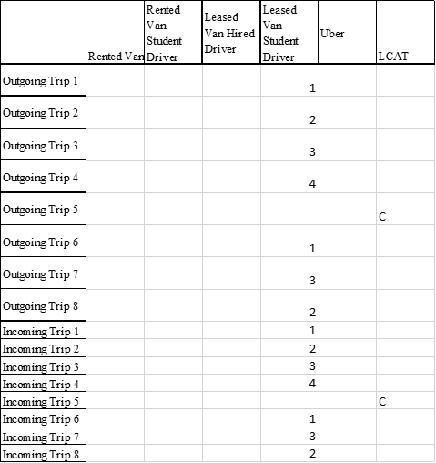

Tuesday:

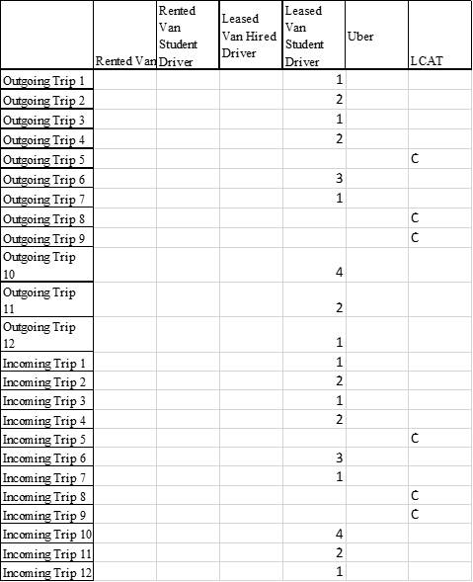

Wednesday:

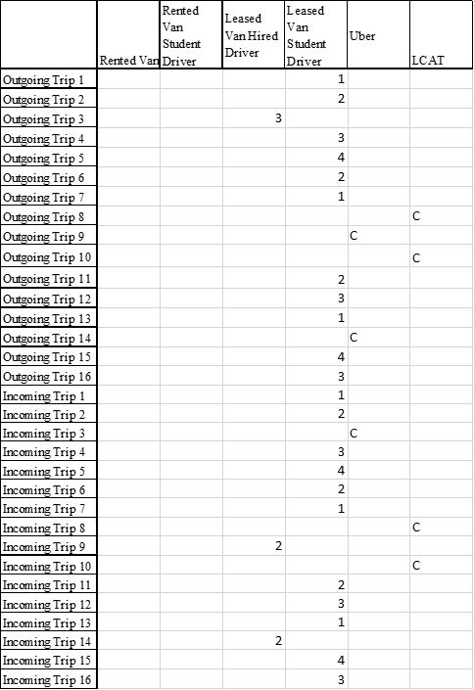

Thursday:

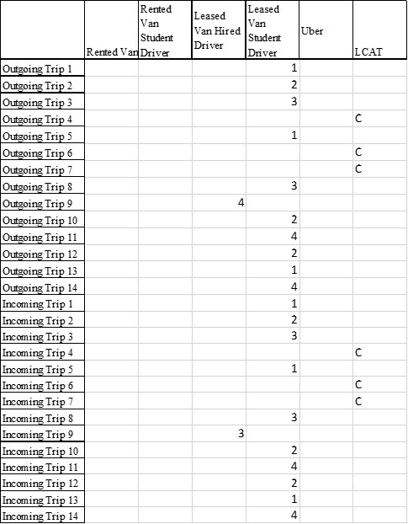

Friday:

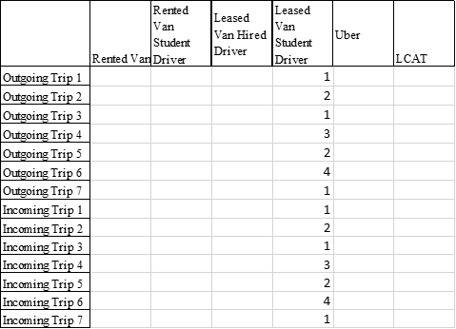

The following table includes variables not referenced in the body of the paper that are used in some of the constraints discussed in this Appendix.

|  |  |
| --- | --- |
| $$LS_{ik}$$ | These represent binary decision variables that assumes values of one if the ith leased van is driven on the kth day by a student participating in the program they drive to |
| $$LH_{ik}$$ | These represent binary decision variables that assumes values of one if the ith leased van is driven on the kth day by a student not in the program hired to drive |
| $$RS_{ik}$$ | These represent binary decision variables that assumes values of one if the ith rented van is driven on the kth day by a student participating in the program they drive to |
| $$RH_{ik}$$ | These represent binary decision variables that assumes values of one if the ith rented van is driven on the kth day by a student not in the program hired to drive |
| $$NR_{ik}$$ | These represent binary variables corresponding to whether the ith rented van is rented on the kth day |

For equations (1) Through (13), $M$ is a constant, and is set to a value that is arbitrarily very large. This is mechanistic for our constraints to our “if-then” constraints to work together properly.

Equations (1) and (2) together constrain for the following if-then statement: If the $i^{th}$ rented van is at any point used by a student driver on the $k^{th}$ day, then the binary variable $RS_{ik}$ must be 1, and is 0 otherwise.

|  |  |  |
| --- | --- | --- |
|  | $RS_{ik} ≤ \sum_{f}{}\sum_{b}{}(RS_{ibk}+RS_{ifk})$ (1) |  |

|  |  |  |
| --- | --- | --- |
|  |  | (2) |

Equations (3) and (4) follow the same logic as equations (1) and (2), but for rented vans used by hired drivers.

|  |  |  |
| --- | --- | --- |
|  | $$RH_{ik} ≤ \sum_{f}{}\sum_{b}{}(RH_{ibk}+RH_{ifk})$$ | (3) |

|  |  |  |
| --- | --- | --- |
|  |  | (4) |

Equations (5) and (6) together constrain for the following if-then statement: If the $i^{th}$ rented van is ever used (whether as student-driven, hired-driven, or both) on the $k^{th}$ day, then the binary variable $NR_{ik}$ must be 1, and is 0 otherwise.

|  |  |  |
| --- | --- | --- |
|  | $NR_{ik} ≤ RS_{ik} + RH_{ik}$ | (5) |

|  |  |  |
| --- | --- | --- |
|  |  | (6) |

Equation (7) finds the total number of rented vans, $NR_{k}$ used on the $k^{th}$ day.

|  |  |  |
| --- | --- | --- |
|  | $$\sum_{i}{}NR_{ik} = NR_{k}$$ | (7) |

Equations (8) through (14) follow the same logic as equations (1) through (7), except its for leased vans instead.

|  |  |  |
| --- | --- | --- |
|  | $LS_{ik} ≤ \sum_{f}{}\sum_{b}{}(LS_{ibk}+LS_{ifk})$ | (8) |

|  |  |  |
| --- | --- | --- |
|  |  | (9) |

|  |  |  |
| --- | --- | --- |
|  |  | (10) |

|  |  |  |
| --- | --- | --- |
|  |  | (11) |

|  |  |  |
| --- | --- | --- |
|  |  | (12) |

|  |  |  |
| --- | --- | --- |
|  |  | (13) |

|  |  |  |
| --- | --- | --- |
|  |  | (14) |

Equation (15) basically serves as a “max” function as it keeps track of the number of leased vans $NL_{k}$ needed for each $k^{th}$ day and stores the maximum of all of these values as $NL$.

|  |  |  |
| --- | --- | --- |
|  | $$NL ≥ NL_{k} for all k$$ | (15) |

**Our Incomplete and Unincluded Idea:**

We attempting to create a more realistic way to deal with the student scheduling, but couldn’t quite pull it off in the time constraint. However, if allotted more time, we think this feature would create a more realistic and thus effective model. Right now, our model assumes that a hired student driver could complete one trip for their shift. Based on our assumptions, this is a 15 minute long shift, which would only amount to a few dollars pay, and thus most students would not be interested in this job. So, we intend to find paths between routes that allow for shifts at least 2 hours in length and no more than 4 hours in length under the assumption that this would attract more drivers, as this is a long enough shift to allow for sufficient compensation, but also not long enough to stifle a student’s ability to attend to their classwork. To do this, we created graphs for each day of the week where each node represents a route and the edges of the graph correspond to the amount of time between each route. From previous assumptions we know the amount of time between each route must be half an hour in order to allow for the driver to make both destinations. We set an upper bound on this time intersection which we refer to as “lag time” as one hour, which translates to half an hour maximum in which the student is waiting to pick people up and not actively driving, under the assumption that it is bad business practice to pay a student for not driving for a period longer than half an hour at a time. We used an Excel workbook to check for intersections between routes of this time length and then generated the following graphs in MatLab.

Our intention was to use the graphs to map out possible routes given the aforementioned time restriction and implement these into our set of constraints so that when the program considers placing hired drivers, it considers the possible paths we identified.

Monday Graph:

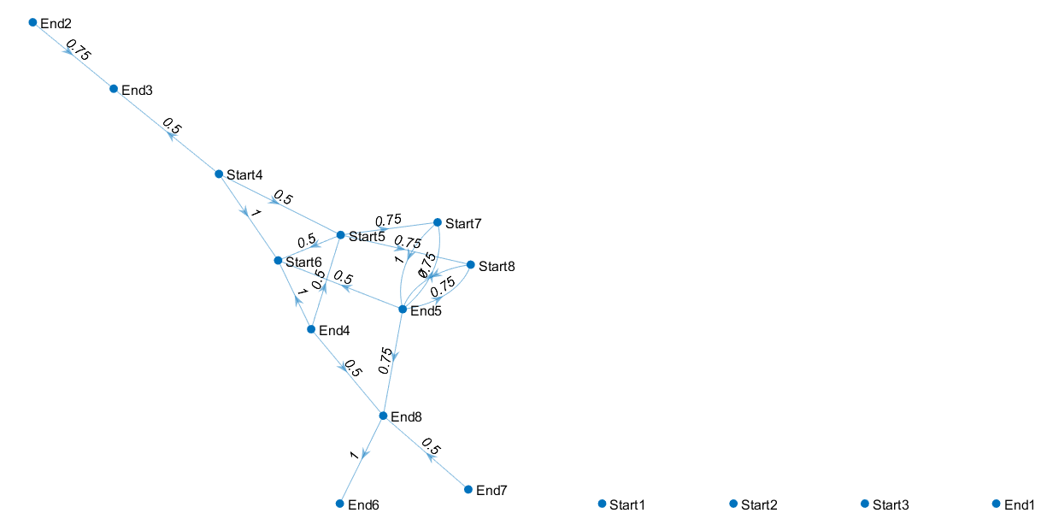

Tuesday Graph:

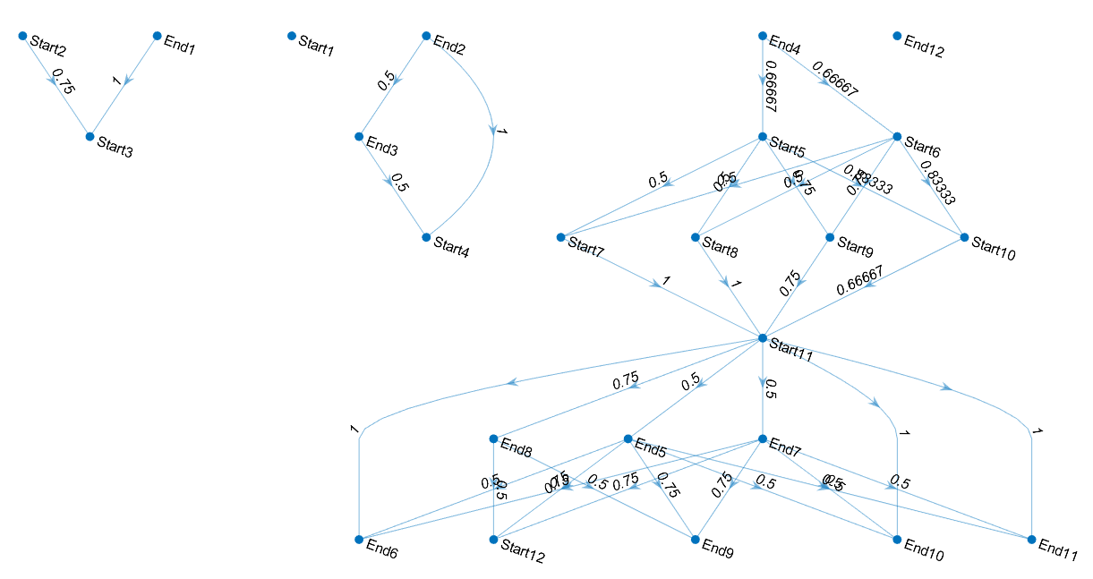

Wednesday Graph:

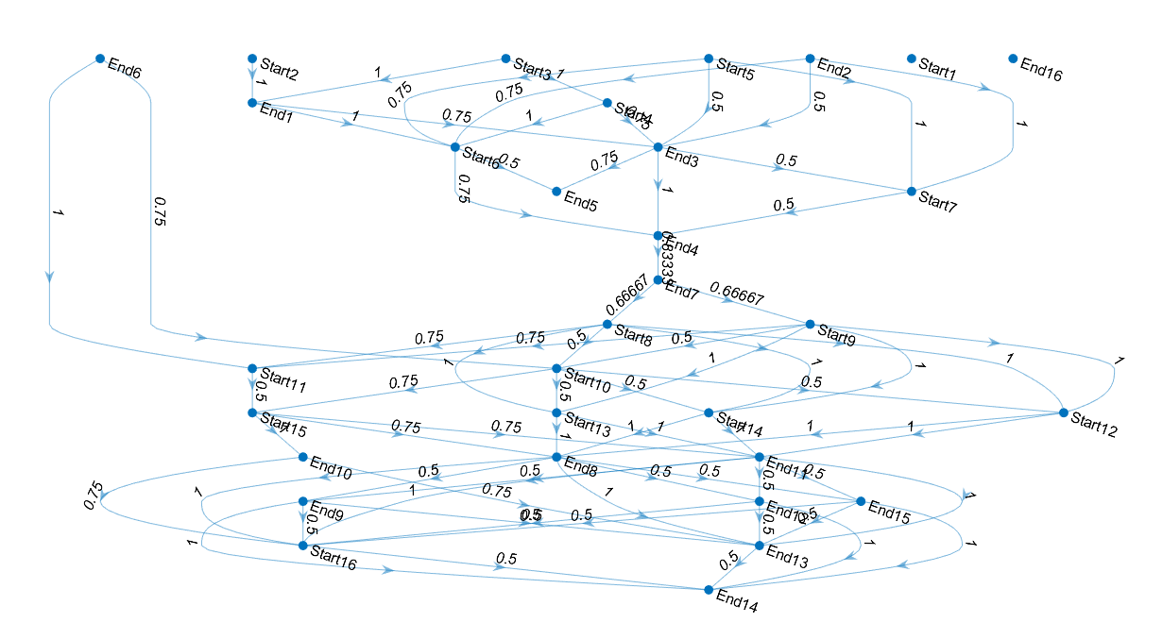

Thursday Graph: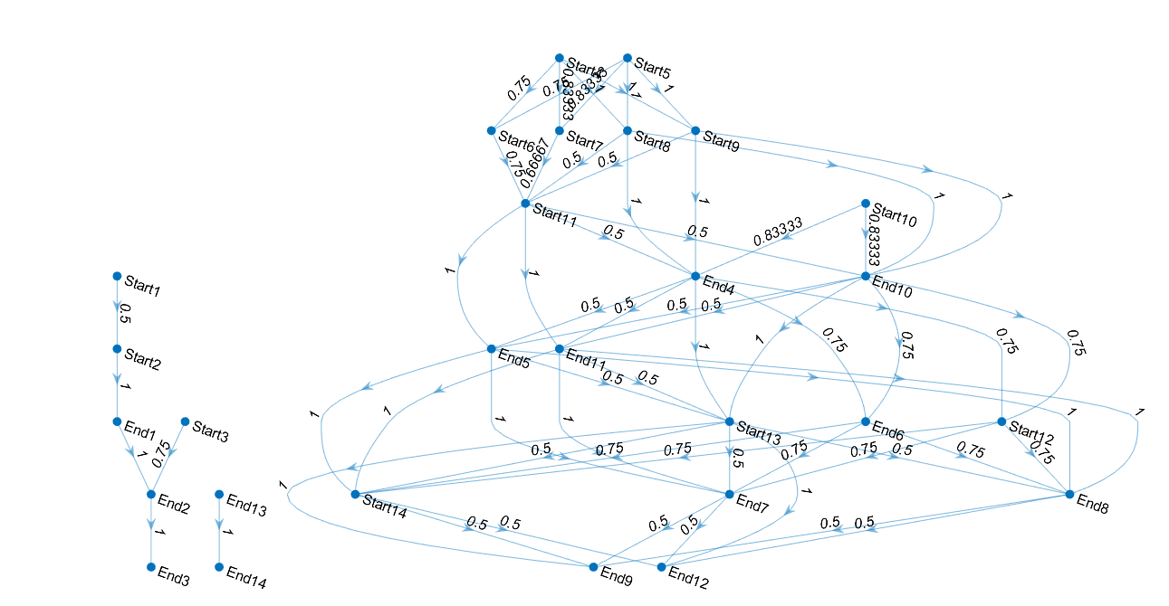

Friday Graph:

